Company Announcement
For Immediate Release – 9 January 2018
PraxisIFM Group Limited (the “Company”)

Re: PDMR Declaration

The Directors of the Company are pleased to announce the appointment of Mr Kevin Scott as Chief Operating Officer of the Company with effect from 8 January 2018, which is an executive appointment.

As a result of this appointment, he has been granted options over 1.8m ordinary shares with an exercise price of GBP1.40 as follows:
· 600,000 exercisable on 8 January 2018
· 600,000 exercisable when share price reaches £1.60
· 600,000 exercisable when share price reaches £2.00
A copy of the media release is attached to this announcement.

Further enquiries:
Ravenscroft Limited
01481 729100

END OF ANNOUNCEMENT

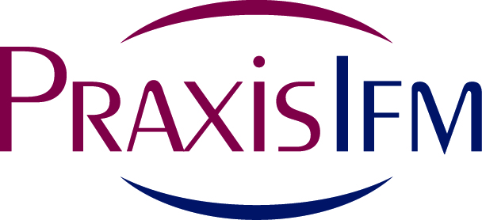

Media release 9 January 2018
KEY STRATEGIC HIRE AT PRAXISIFM

PraxisIFM has created a new Group Operating Officer role as part of its plan to further grow its international business.

Kevin Scott’s appointment comes after a busy period for the Channel Islands-based Group, following the acquisitions of Kompas International, Private Equity Services and RiskCo Group, and the expansion of its UK trust and corporate services offering.

Group CEO, Dr Simon Thornton, said: ‘We’re delighted someone with Kevin’s experience is joining us. His experience in building and managing a very successful international business will be invaluable to us and I’m looking forward to working with him.’
Mr Scott has more than 20 years’ experience at senior level with well-known asset management groups. Most recently he was head of EMEA and UK at Jupiter Asset Management. He set up the international business of Jupiter in 2006 and while there established and managed large teams across the UK, Europe, the UAE and Asia over an 11 year period and through Jupiter’s MBO and then IPO in 2010.

‘I am really looking forward to joining PraxisIFM and I hope to bring my experience in strategic planning, operations and relationship building to the Group at this exciting time in its development,’ said Mr Scott.

Mr Scott is a former international badminton player, representing Scotland and Great Britain for almost a decade before retiring from the sport in 1996. He was a board member of governing body Badminton Europe from 2011 to 2017.

- ends -

Issued by Tracey O’Neill, Marketing and BD Manager, 01481 737658
Tracey.oneill@praxisifm.com

Notes to editors

PraxisIFM Group
The PraxisIFM Group, which is listed on The International Stock Exchange, is one of the largest independent financial services groups headquartered in the Channel Islands. The Group reported revenues of more than £35 million in the year to 30 April 2017. Following its recent acquisitions, it has more than 425 staff across multiple global jurisdictions.

The Group’s core activities are Trust and Corporate Administration, Fund Administration, and Pension Administration.
www.praxisifm.com

